***C++ LAB TASK-3 SOLUTIONS***

**1. Write a program in C++ to store elements in an array and print it.**

**#include<iostream>**

**using namespace std;**

**class displ**

**{**

**public:**

**int arr[10];**

**int i;**

**};**

**int main()**

**{ displ d1;**

**cout<<"Read and Print elements of an array:"<<endl;**

**cout<<"-----------------------------------------"<<endl;**

**cout<<"Input 10 elements in the array :"<<endl;**

**for(d1.i=0; d1.i<10; d1.i++)**

**{**

**cout<<"element :",d1.i;**

**cin>>d1.arr[d1.i];**

**}**

**cout<<"Elements in array are:";**

**for(d1.i=0; d1.i<10; d1.i++)**

**{**

**cout<<d1.arr[d1.i]<<" ";**

**}**

**cout<<endl;**

**return 0;**

**}**

**Output:**

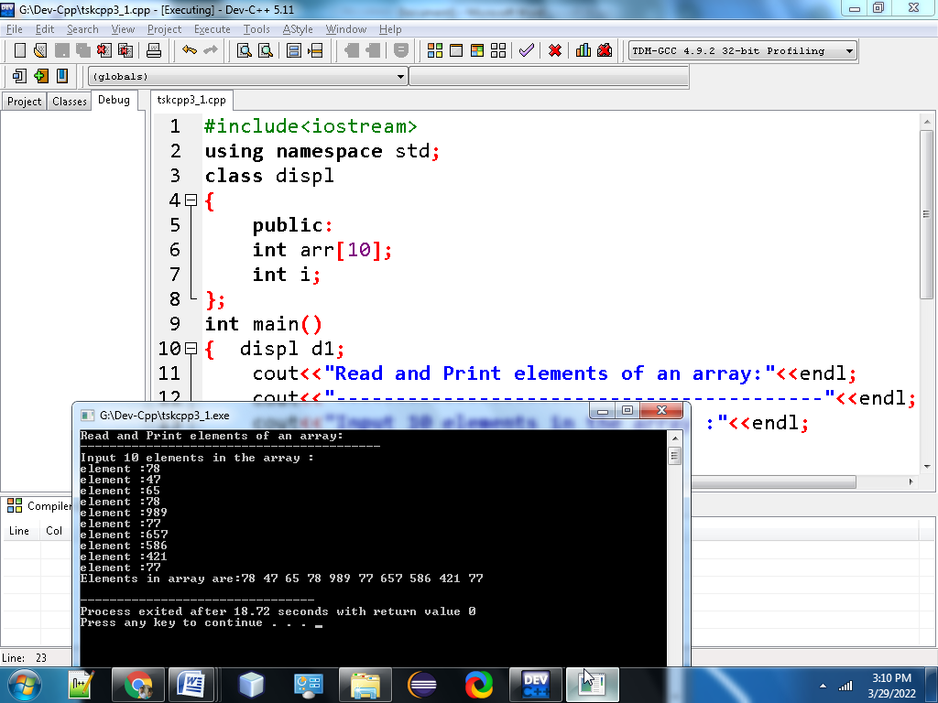

2.Write a program in C++ to read n number of values in an array and display it in reverse order. ?

#include <iostream>

using namespace std;

class rev

{

public:

int i,n,a[100];

};

int main()

{

rev r;

cout<<"Read n number of values in an array and display it in reverse order:"<<endl;

cout<<"------------------------------------------------------------------------"<<endl;

cout<<"Input the number of elements to store in the array :";

cin>>r.n;

cout<<"Input"<<r.n<<"number of elements in the array:"<<r.n<<endl;

for(r.i=0;r.i<r.n;r.i++)

{

cout<<"element-"<<r.i<<endl;

cin >>r.a[r.i];

}

cout<<"The values store into the array are :"<<endl;

for(r.i=0;r.i<r.n;r.i++)

{

cout<<r.a[r.i]<<" ";

}

cout<<"\n"<<"The values store into the array in reverse are:"<<endl;

for(r.i=r.n-1;r.i>=0;r.i--)

{

cout<<r.a[r.i]<<" ";

}

cout<<"\n"<<"\n";

return 0;

}

Output:

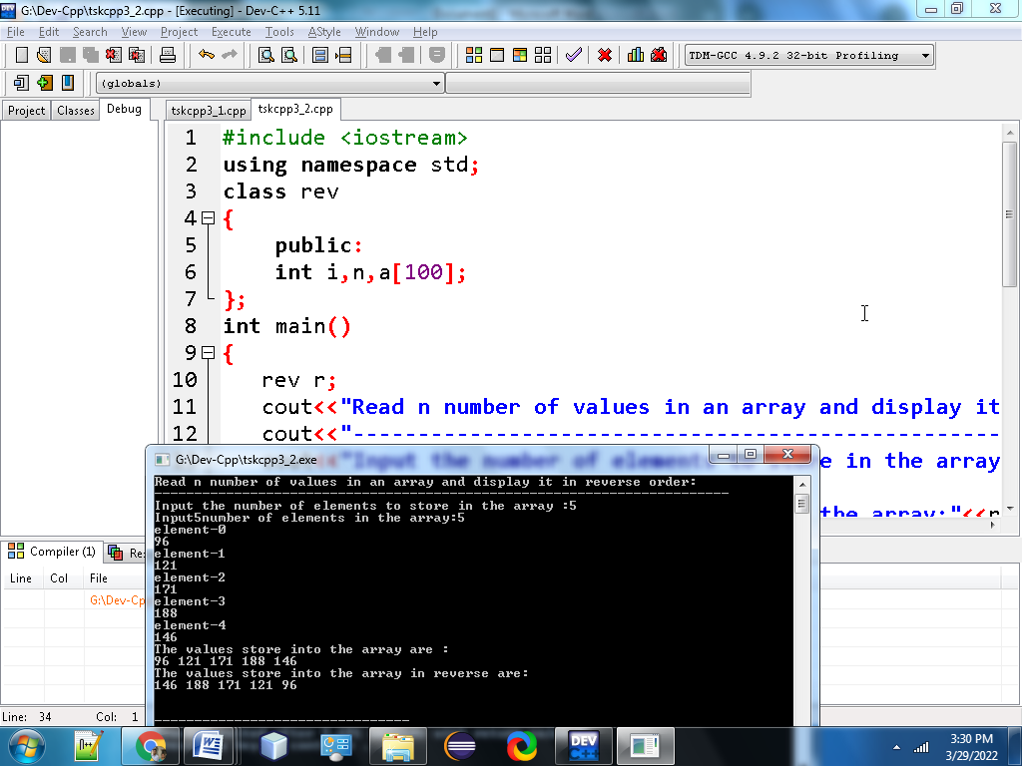

**3. Write a program in C++ to find the sum of all elements of the array.**

**#include<iostream>**

**using namespace std;**

**class sum**

**{**

**public:**

**int a[100];**

**int i,n,sum=0;**

**};**

**int main()**

**{**

**sum s;**

**cout<<"Find sum of all elements of array:"<<"\n";**

**cout<<"--------------------------------------"<<"\n";**

**cout<<"Input the number of elements to be stored in the array :"<<endl;**

**cin>>s.n;**

**cout<<"Input %d elements in the array :"<<"\n"<<s.n;**

**for(s.i=0;s.i<s.n;s.i++)**

**{**

**cout<<"element:"<<s.i;**

**cin>>s.a[s.i];**

**}**

**for(s.i=0; s.i<s.n; s.i++)**

**{**

**s.sum += s.a[s.i];**

**}**

**cout<<"Sum of all elements stored in the array is :"<<"\n\n"<<s.sum;**

**return 0;**

**}**

**Output:**

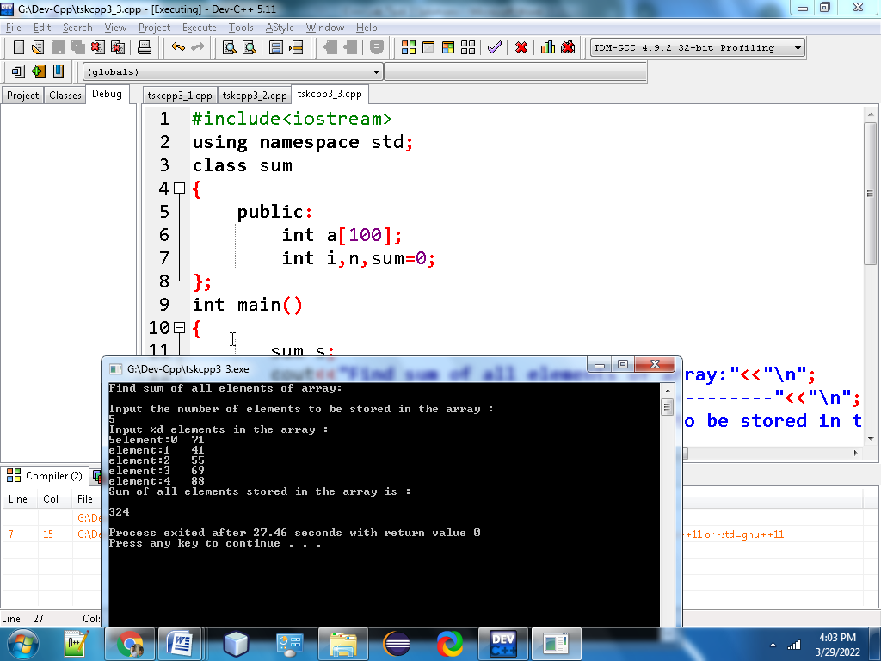

**4.** Write a program in C++ to copy the elements of one array into another array?

#include <iostream>

using namespace std;

class oto

{

public:

int arr1[100], arr2[100];

int i, n;

};

int main()

{

oto ot;

cout<<"\n\nCopy the elements one array into another array :\n";

cout<<"----------------------------------------------------\n";

cout<<"Input the number of elements to be stored in the array :";

cin>>ot.n;

cout<<"Input elements in the array :\n"<<ot.n;

for(ot.i=0;ot.i<ot.n;ot.i++)

{

cout<<"element: "<<ot.i;

cin>>ot.arr1[ot.i];

}

for(ot.i=0; ot.i<ot.n;ot.i++)

{

ot.arr2[ot.i] = ot.arr1[ot.i];

}

cout<<"\nThe elements stored in the first array are :\n";

for(ot.i=0; ot.i<ot.n; ot.i++)

{

cout<<ot.arr1[ot.i]<<" ";

}

cout<<"\n\nThe elements copied into the second array are :\n";

for(ot.i=0; ot.i<ot.n; ot.i++)

{

cout<<ot.arr2[ot.i]<<" ";

}

cout<<"\n\n";

return 0;

}

Output:

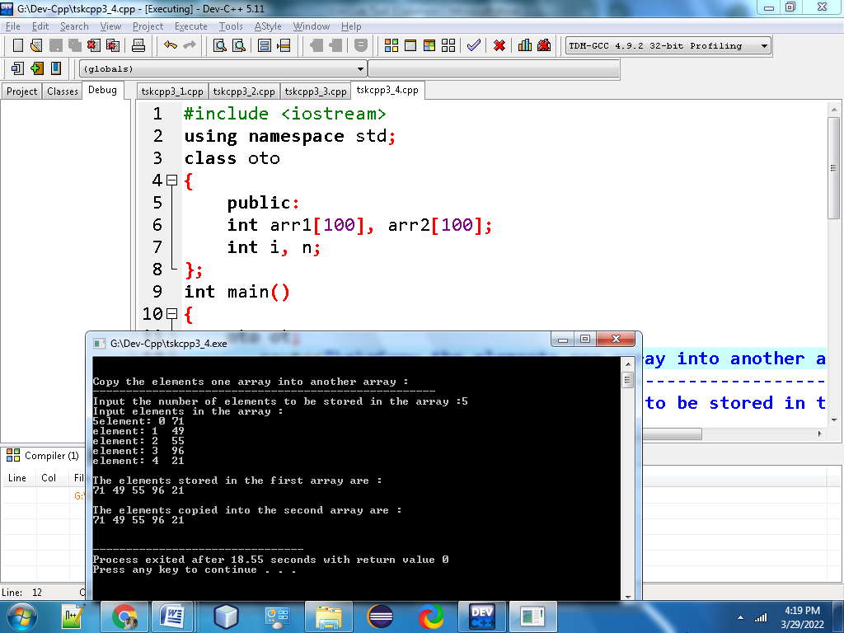

**5. Write a program in C++ to count a total number of duplicate elements in an array?**

**#include <iostream>**

**using namespace std;**

**class dup**

**{**

**public:**

**int arr1[100];**

**int arr2[100];**

**int arr3[100];**

**int n,mm=1,ctr=0;**

**int i, j;**

**};**

**int main()**

**{**

**dup d;**

**cout<<"\n\nCount total number of duplicate elements in an array:\n";**

**cout<<"---------------------------------------------------------\n";**

**cout<<"Input the number of elements to be stored in the array :";**

**cin>>d.n;**

**cout<<"Input elements in the array:\n"<<d.n;**

**for(d.i=0;d.i<d.n;d.i++)**

**{**

**cout<<"element : "<<d.i;**

**cin>>d.arr1[d.i];**

**}**

**for(d.i=0;d.i<d.n; d.i++)**

**{**

**d.arr2[d.i]=d.arr1[d.i];**

**d.arr3[d.i]=0;**

**}**

**for(d.i=0;d.i<d.n; d.i++)**

**{**

**for(d.j=0;d.j<d.n;d.j++)**

**{**

**if(d.arr1[d.i]==d.arr2[d.j])**

**{**

**d.arr3[d.j]=d.mm;**

**d.mm++;**

**}**

**}**

**d.mm=1;**

**}**

**for(d.i=0; d.i<d.n; d.i++)**

**{**

**if(d.arr3[d.i]==2){d.ctr++;}**

**}**

**cout<<"The total number of duplicate elements found in the array is:\n"<<d.ctr;**

**cout<<"\n\n";**

**return 0;**

**}**

**Output:**

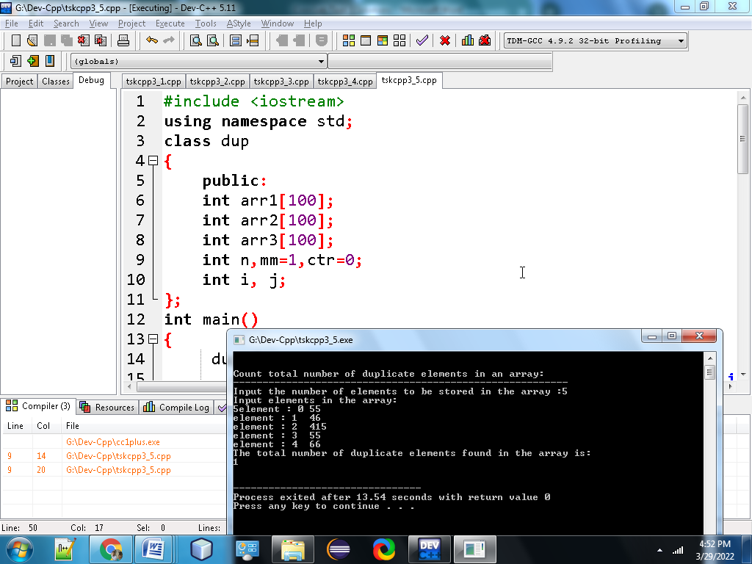

**6. Write a program in C++ to print all unique elements in an array?**

**#include<iostream>**

**using namespace std;**

**class uni**

**{**

**public:**

**int array1 [11] = {1, 5, 7, 5, 8, 9, 11, 11, 2, 5, 6};**

**int s1 = sizeof(array1)/sizeof(array1[0]);**

**};**

**int main()**

**{**

**uni u;**

**cout << "Original array: ";**

**for (int i=0; i < u.s1; i++)**

**cout << u.array1[i] <<" ";**

**cout <<"\nUnique elements of the said array: ";**

**for (int i=0; i<u.s1; i++)**

**{**

**int j;**

**for (j=0; j<i; j++)**

**if (u.array1[i] == u.array1[j])**

**break;**

**if (i == j)**

**cout << u.array1[i] << " ";**

**}**

**return 0;**

**}**

**Output:**

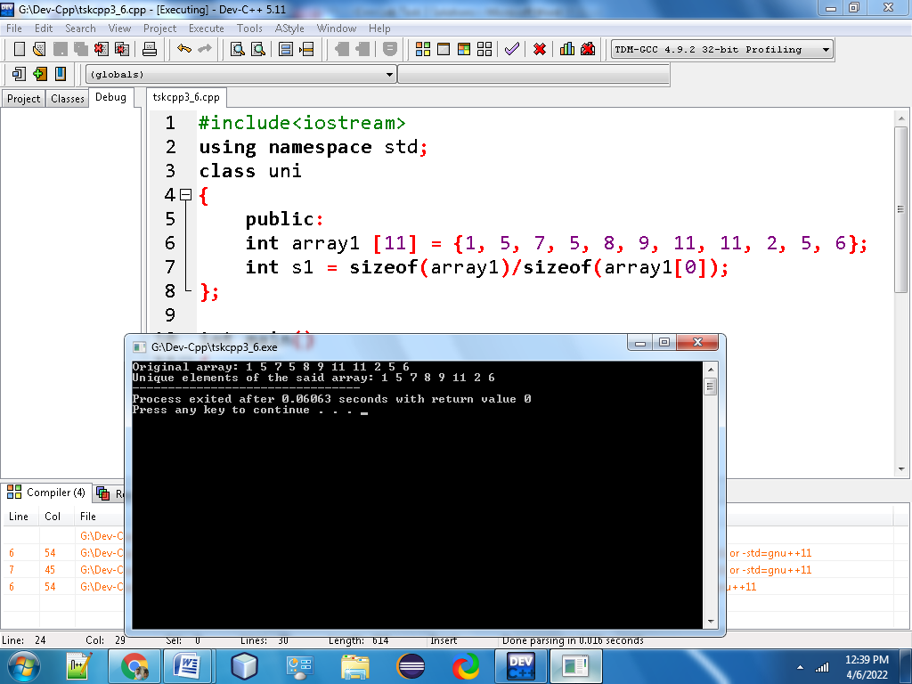

**7) Write a program in C++ to merge two arrays of same size sorted in descending order**

**#include<iostream>**

**using namespace std;**

**class merge**

**{**

**public:**

**int arr1[20], arr2[20],merge[50];**

**int n,n1,n2,k,i,temp;**

**};**

**int main()**

**{**

**merge m;**

**cout<<"Enter The size for first array";**

**cin>>m.n1;**

**cout<<"Enter "<<m.n1<<"elements of first array:\n";**

**for(m.i=0;m.i<m.n1;m.i++)**

**{**

**cin>>m.arr1[m.i];**

**m.merge[m.i]=m.arr1[m.i];**

**}**

**m.k=m.i;**

**cout<<"Enter The size for second array";**

**cin>>m.n2;**

**cout<<"Enter "<<m.n2<<"elements of second array:\n";**

**for(m.i=0;m.i<m.n2;m.i++)**

**{**

**cin>>m.arr2[m.i];**

**m.merge[m.k]=m.arr2[m.i];**

**m.k++;**

**}**

**m.n=m.k;**

**for(int j=0;j<m.n-1;j++)**

**{**

**for(m.i=0;m.i<m.n-1;m.i++)**

**{**

**if(m.merge[m.i]<m.merge[m.i+1])**

**{**

**m.temp=m.merge[m.i];**

**m.merge[m.i]=m.merge[m.i+1];**

**m.merge[m.i+1]=m.temp;**

**}**

**}**

**}**

**cout<<"\nMerged Array:";**

**for(m.i=0;m.i<m.k;m.i++)**

**{**

**cout<<m.merge[m.i]<<"";**

**cout<<endl;**

**}**

**return 0;**

**}**

**Output:**

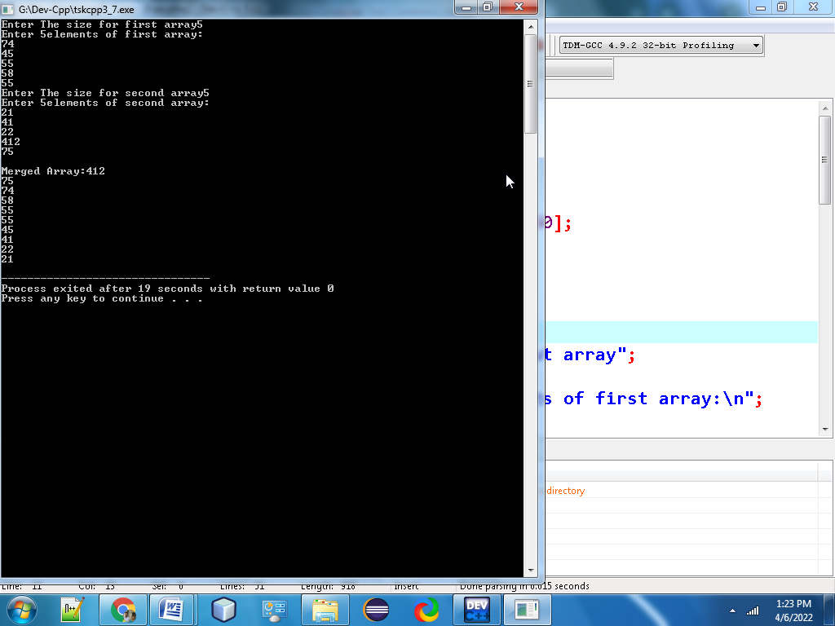

**8. Write a program in C++ to count the frequency of each element of an array?**

**#include <iostream>**

**using namespace std;**

**class freq**

**{**

**public:**

**int freq[100];**

**int size, i, j, count;**

**};**

**int main()**

**{**

**freq f;**

**cout << "\nEnter size of array:";**

**cin >> f.size;**

**int arr[f.size];**

**cout << "\nEnter elements in array:";**

**for(f.i=0; f.i<f.size; f.i++)**

**{**

**cin >> arr[f.i];**

**f.freq[f.i] = -1;**

**}**

**for(f.i=0; f.i<f.size; f.i++)**

**{**

**f.count = 1;**

**for(f.j=f.i+1; f.j<f.size; f.j++)**

**{**

**if(arr[f.i]==arr[f.j])**

**{**

**f.count++;**

**f.freq[f.j] = 0;**

**}**

**}**

**if(f.freq[f.i] != 0)**

**{**

**f.freq[f.i] = f.count;**

**}**

**}**

**cout << "\nFrequency of all elements of array :";**

**for(f.i=0; f.i<f.size; f.i++)**

**{**

**if(f.freq[f.i] != 0)**

**{**

**cout <<"\n" <<arr[f.i] << "occurs" << f.freq[f.i] << "times" << endl;**

**}**

**}**

**}**

**Output:**

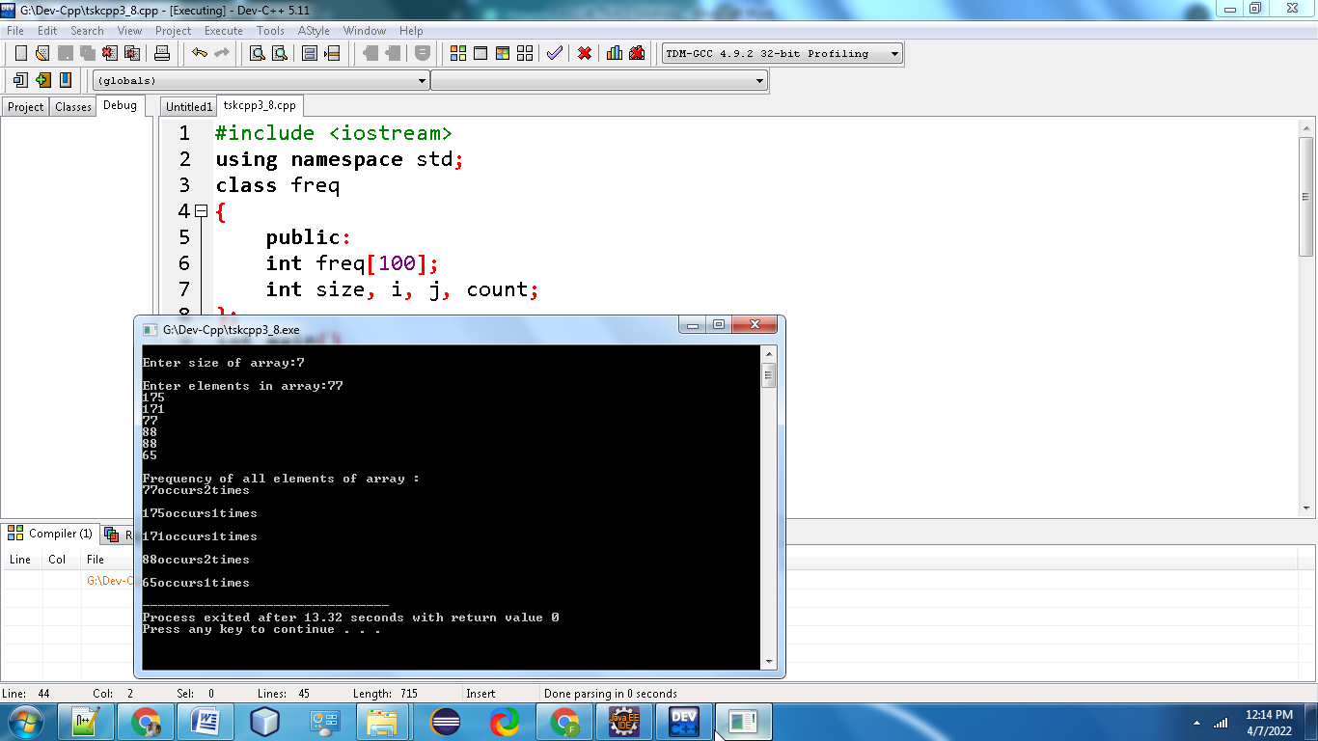

**9.Write a program in C++ to find the maximum and minimum element in an array.**

**#include<iostream>**

**using namespace std;**

**class minmax**

**{**

**public:**

**int arr[10], n, i, max, min;**

**};**

**int main ()**

**{**

**minmax mm;**

**cout << "Enter the size of the array : ";**

**cin >>mm.n;**

**cout << "Enter the elements of the array : ";**

**for (mm.i = 0; mm.i < mm.n; mm.i++)**

**cin >> mm.arr[mm.i];**

**mm.max = mm.arr[0];**

**for (mm.i = 0; mm.i <mm. n; mm.i++)**

**{**

**if (mm.max < mm.arr[mm.i])**

**mm.max = mm.arr[mm.i];**

**}**

**mm.min =mm. arr[0];**

**for (mm.i = 0; mm.i < mm.n; mm.i++)**

**{**

**if (mm.min > mm.arr[mm.i])**

**mm.min = mm.arr[mm.i];**

**}**

**cout << "Largest element : " << mm.max<<endl;**

**cout << "Smallest element : " <<mm. min;**

**return 0;**

**}**

**Output:**

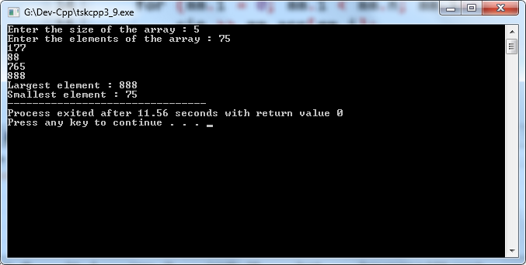

**10.Write a program in C ++ to separate odd and even integers in separate arrays?**

**#include <iostream>**

**using namespace std;**

**class sep**

**{**

**public:**

**int arr[10],even[10],odd[10],evncnt=0,oddcnt=0,i;**

**};**

**int main()**

**{**

**sep s;**

**cout<<"Input numbers in the array";**

**for(s.i=0;s.i<10;s.i++)**

**cin>>s.arr[s.i];**

**for(s.i=0;s.i<10;s.i++)**

**{**

**if(s.arr[s.i]%2==0)**

**s.even[s.evncnt++]=s.arr[s.i];**

**else**

**s.odd[s.oddcnt++]=s.arr[s.i];**

**}**

**cout<<"The even numbers are: ";**

**for(s.i=0;s.i<s.evncnt;s.i++)**

**cout<<s.even[s.i]<<" ";**

**cout<<"\nThe odd numbers are: ";**

**for(s.i=0;s.i<s.oddcnt;s.i++)**

**cout<<s.odd[s.i]<<" ";**

**}**

**Output:**

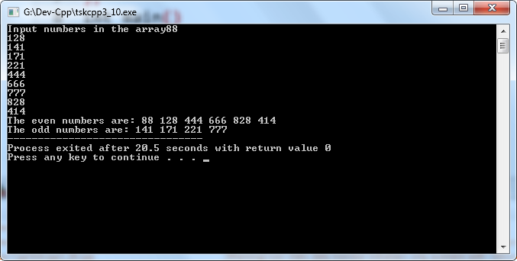

**11. Write a program in C++ to sort elements of array in ascending order?**

**#include <iostream>**

**using namespace std;**

**class sort**

**{**

**public:**

**int arr[100];**

**int size, i, j, temp;**

**};**

**int main()**

**{**

**sort st;**

**cout<<"Enter size of array: ";**

**cin>>st.size;**

**cout<<"Enter elements in array: ";**

**for(st.i=0; st.i<st.size; st.i++)**

**{**

**cin>>st.arr[st.i];**

**}**

**for(st.i=0; st.i<st.size; st.i++)**

**{**

**for(st.j=st.i+1; st.j<st.size; st.j++)**

**{**

**if(st.arr[st.j] < st.arr[st.i])**

**{**

**st.temp = st.arr[st.i];**

**st.arr[st.i] = st.arr[st.j];**

**st.arr[st.j] = st.temp;**

**}**

**}**

**}**

**cout<<"Elements of array in sorted ascending order:"<<endl;**

**for(st.i=0; st.i<st.size; st.i++)**

**{**

**cout<<st.arr[st.i]<<endl;**

**}**

**return 0;**

**}**

**Output:**

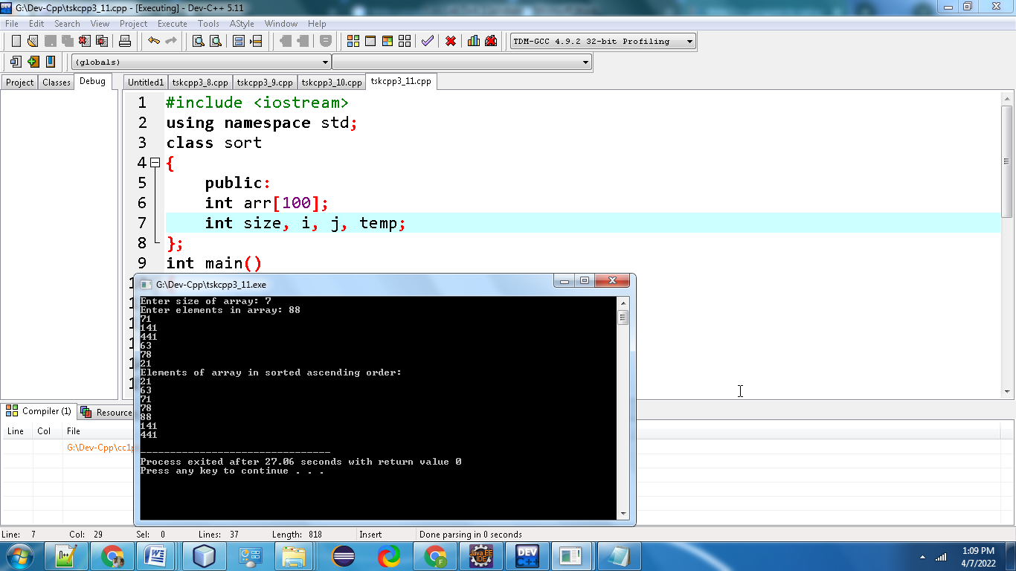

**12. Write a program in C++ to sort elements of the array in descending order?**

**#include<iostream>**

**using namespace std;**

**class des**

**{**

**public:**

**int num[10];**

**int i, j, desc;**

**};**

**int main ()**

**{**

**des d;**

**cout<<"\n Enter 10 Numbers : \n";**

**cout<<" ";**

**for (d.i = 0; d.i < 10; ++d.i)**

**cin>>d.num[d.i];**

**for (d.i = 0; d.i < 10; ++d.i) // 'for' loop is used for sorting the numbers in descending order**

**{**

**for (d.j = d.i + 1; d.j < 10; ++d.j)**

**{**

**if (d.num[d.i] < d.num[d.j])**

**{**

**d.desc = d.num[d.i];**

**d.num[d.i] = d.num[d.j];**

**d.num[d.j] = d.desc;**

**}**

**}**

**}**

**cout<<"\n Numbers in Descending Order : \n";**

**for (d.i = 0; d.i < 10; ++d.i)**

**{**

**cout<<" ";**

**cout<<d.num[d.i];**

**cout<<"\n";**

**}**

**}**

**Output:**

